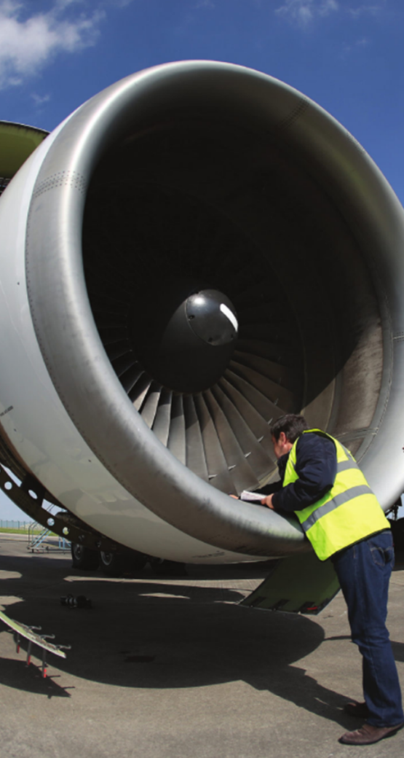
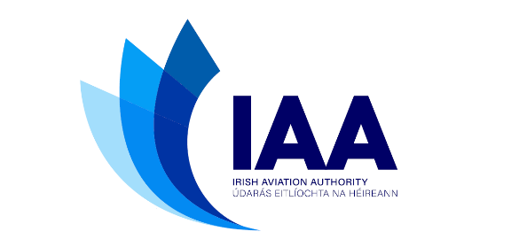

IAA
Statement of Strategy
Stakeholder Consultation
Draft - July 2023

Contents
Chapter 1: Introduction 2
IAA - Who we are 2
Our Mission - What we do 2
Our Values 2
Chapter 2: Key Objectives 1
Effective Regulation 2
Consumer Protection 3
Stakeholder Engagement 4
Our People and Organisation 5
Innovation and Collaboration 6
Exercising influence 7
Environmental Responsibilities 8
Chapter 3: Performance Monitoring 9
Why we monitor performance 9
How we report on performance 9

Chapter 1: Introduction

IAA - Who we are
The IAA is the single civil aviation regulator for Ireland.
We regulate aviation safety, security and consumer interests.
Our responsibilities are set out in the framework of applicable global, European and national legislation/regulation.

Our Mission - What we do
Our mission is to regulate aviation to the highest professional standards to ensure a safe, secure and consumer-focused aviation environment. Through regulation, we will enable and support world-class performance and innovation in civil aviation in Ireland and abroad.

Our Values

Safety is at the core of what we do
We are the experts and the authority in our field.
The passenger is central
We protect the interests of passengers in everything we do.
We champion excellence
Individually and collectively, we ensure that our practices and performance are of the highest standard in global aviation, consistently implemented and subject to continuous improvement.
Our value is in our people
Our professionalism and commitment are at the heart of everything we do.
Clear and responsive
We are accessible. We meet and surpass our public service commitments and strive to provide clarity and promote understanding in all aspects of regulation.
Collaborative
We promote teamwork within the Authority, and work with stakeholders and clients to find solutions.
We promote sustainable and responsible practices
Aiming to promote the development of aviation in a sustainable and responsible way, meeting the imperative to protect our shared environment.

Comment:
Suggested Changes (if any)

Chapter 2: Key Objectives
In delivering on our Mission and aligned with our core values, we will ensure the best use of our available resources by focussing on the following key objectives and related strategies:
- Effective regulation
- Consumer protection
- Stakeholder Engagement
- Our people and organisation
- Innovation and Collaboration
- Exercising Influence
- Environmental Responsibility

Comment:
Suggested Changes (if any)

Effective Regulation
We aim to deliver effective safety, security, economic and consumer protection regulation in line with Global Standards and European Regulations and best practice
Our strategy
- Implement the State Safety Programme for Ireland, with an effective State Plan for Aviation Safety detailing the key safety priorities.
- Improve risk management, Just Culture and performance monitoring processes in conjunction with stakeholders
- Integrate security considerations that may impact safety, including cyber security, into our oversight system
- Enhanced regulatory change management processes and greater supports for regulated entities
- Develop new competencies in areas of data analytics, cyber security, UAS operations & certification
- Integrate SMS/SeMS competencies & risk-based oversight in all domains
- Improve safety and security promotion capabilities
- Improve safety promotion approach through stakeholder engagement
- Deliver Airport charges regulation which is in the best interest of users of Dublin Airport
- Develop Performance schemes for ATM/ANS Service Providers under the single sky regulations which meet the needs of airspace users
- Promote competition and facilitate new entry with airport slot regulation
- Deliver effective oversight of the travel trade, ground-handlers and airlines
- Develop and implement fit-for-purpose charging arrangements

Our expectations
- Updated State Safety Programme published
- Enhanced safety management and change management processes in new IAA
- New competencies developed to address evolving requirements
- Enhanced stakeholder collaboration processes implemented
- Status of implementation of regulations and oversight in line with statutory requirements and committed timelines

Comment:
Suggested Changes (if any)

Consumer Protection
We aim to enhance aircraft passenger experience in respect of Consumer Protection, Value and Choice

Our Strategy
- Involve consumers in our regulatory decision-making processes
- Strengthen the voice of the Passenger Advisory Group in relevant regulatory decisions
- Drive an increase consumer and industry engagement in consumer protection
- Ensure that consumer rights are upheld
- Develop a new consumer communications strategy
- Strengthen protection of Consumer Rights through the development of a customer charter

Our expectations
- New Customer Charter developed
- New consumer communications strategy developed
- Enhanced engagement with Passenger Advisory Group and consumers
- Customer rights upheld under Air Passenger Rights (APR) and Persons with Reduced Mobility (PRM) legislation

Comment:
Suggested Changes (if any)

Stakeholder Engagement
We aim to enhance our engagement with our Industry Customers, Licence Holders & Aviation Stakeholders

Our Strategy
- Broader participation in our regulatory processes via appropriate consultation processes, the Aviation Stakeholder Forums and safety/regulatory workshops
- Develop a Licence Holders Charter
- Provide clear information on processes, including compliance requirements
- Facilitate inputs from those impacted by regulatory burden
- Provide clear, relevant and timely information to those impacted by regulatory actions
- Provide updates to stakeholder on sectoral developments
- Develop and maintain effective arrangements to communicate with industry customers, licence holders & stakeholders

Our expectations
- Licence Holders Charter developed
- Stakeholder forum established and meetings convened
- Enhanced consultation and communications processes implemented to the satisfaction of stakeholders

Comment:
Suggested Changes (if any)

Our People and Organisation
We aim to enable and support our People to be the best they can be and provide the organisation necessary to deliver on our responsibilities to the highest standards

Our strategy
- Put our people at the centre of our organisation to deliver a quality service to customers
- Promote excellence in everything we do
- Successful integrate IAA and previous CAR staff within a positive organisational culture
- Implement HR policies based on principles of equality and respect for diversity
- Manage factors affecting employee wellbeing
- Deliver a work-life balance policy, including remote-working opportunities
- Deliver a training/development plan for all our people
- Development of a new internal communications strategy, which aims to develop a strong integrated working culture in the ‘new IAA’
- Create a new brand identity and values for the organisation and staff to live by

Our expectations
- New IAA organisation implemented, with associated HR policies and new IAA brand identity
- Training and development plan implemented for all staff in new IAA
- Internal communication strategy updated to address new IAA
- Staff survey conducted to ascertain the effectiveness of implementation of new organisation

Comment:
Suggested Changes (if any)

Innovation and Collaboration
We aim to be an innovative regulator that is ready to support and collaborate with industry on the introduction of new products and services
Our strategy

Use digitalisation to transform our business model
- Develop processes to deliver the full potential of the digitalisation platform
- Deliver improved safety and business-performance intelligence for consumer’s benefit
- Use ‘new intelligence’ business and regulatory data to optimise regulatory oversight
- Develop commercial opportunities for use of our digital solution by other regulators
- Transform all licence and application processes to a digital system enabling staff and customers work through a mobile, online platform
- Fully integrate software solutions operated within the organisation for greater internal and external collaboration

Position the IAA as a best-in-class aviation regulator to the benefit of the Irish Civil aviation system
- Work collaboratively with other national and international regulators to develop and share best practices
- Offer international access to IAA training courses and examination facilities
- Further develop co-operation with EASA and engagement in EASA partnership contract work

Develop a tailored approach to facilitate aircraft leasing transactions
- Provide focussed services for the registration, storage and cross border transfer of aircraft
- Ensure regulatory support for maintenance check flights and other support flights under EASA regulation

Regulate and support the development of unmanned aviation in Ireland
- Deliver IAA Roadmap for unmanned aviation, building operational capacity and innovation
- Support industry innovation and champion progress at European and Global levels
- Ensure the extensive Irish operational experience is appropriately considered at European and Global level, particularly during rule making activity.

Our expectations
- Digital applications available and in use across all domains in civil aviation, with commercial opportunities associated with digital applications materialised
- Evidence of successful collaboration with other States and EASA
- Increased external participation in IAA training courses on offer
- Increased activities under EASA partnership contract
- Increased support provided to leasing industry as evidenced by increased activity for IAA in this sector
- IAA Roadmap for Unmanned Aviation developed, with implementation of Roadmap in line with major milestones

Comment:
Suggested Changes (if any)

Exercising influence
We aim to support and influence Aviation Regulation and policy development at European and Global Levels
Our strategy
- Participate in ICAO and EC/EASA working groups to help develop future standards and regulations in response to aviation safety priorities, regulatory economics and industry needs
- Support the introduction of a global Electronic Pilot Licence and encourage the development of other electronic licences and certificates in aviation
- Promote new training approaches for licensed pilots and engineers
- Support growth of crew support programmes for aviation personnel and encourage exchange of information in EU on their implementation.
- Develop best practice for economic regulation (guidelines and policy) for airport charges and single sky regulation
- Simplify cross-border transfer of aircraft & electronic records of aircraft through pro-active engagement in European and global policy making activity

Our expectations
- Effective participation in ICAO/EC/EASA working groups supporting rulemaking and policy development
- Status of implementation of key regulatory and policy development projects in line with major milestones

Comment:
Suggested Changes (if any)

Environmental Responsibilities
We aim to meet or exceed our environmental responsibilities and to consider environmental factors in regulatory decision making.

Our strategy
- Place environmental considerations in the regulatory decision-making framework where appropriate
- Support development of environmentally friendly aviation initiatives
- Meet or exceed 2019 Climate Action Plan targets
- Develop and implement an IAA environment action plan
- Support aviation sector drive to net zero carbon by 2050
- Input, as appropriate, to Irish, EU and global environmental policy development

Our expectations
- IAA Environmental Team established
- IAA Environmental Action Plan developed
- Enhanced level of engagement with ICAO, EC/EASA and industry on climate action

Comment:
Suggested Changes (if any)

Chapter 3: Performance Monitoring

Why we monitor performance
Performance monitoring is a key pillar of the safety management processes implemented by the IAA as part of the State Safety Programme. The primary function of performance monitoring as envisaged in ICAO Annex 19 is to provide assurance that the objectives we have set are being met, and this may be accomplished through development of performance indicators.
As part of our state Safety programme responsibilities, we measure and monitor performance at different levels of the civil aviation system, including at organisational, sector and total system levels.

How we report on performance
The performance indicators that support the IAA strategic objectives are monitored at sector and total system levels and contain a range of disparate metrics and status updates. Much of this information is reported on an annual basis via the following documents:
- The IAA Annual Report, and Final Accounts and Final Annual Report Economic
- The IAA Annual Safety Performance Statement
- The IAA Annual Safety Performance Review
- The State Plan for Aviation Safety

Comment:
Suggested Changes (if any)

