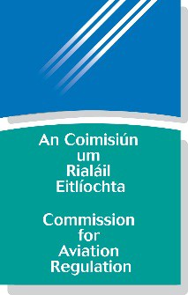

Commission for Aviation Regulation

Head of Economic Regulation

Name: Title of Post:

Having read the competencies and thought about the demands of the role, for each of the areas below, please briefly (max 250 words for each) highlight specific achievements, contributions or expertise you have developed during your career to date which clearly demonstrate your suitability to meet the challenges of the role.

Leadership & Strategic Direction
Judgement & Decision Making
Management & Delivery of Results
Building Relationships & Communication
Specialist Knowledge, Expertise & Self-Development

Drive and Commitment to Public Service Values

