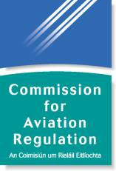

Passenger Rights Complaints in 2011

31st July 2012
Commission for Aviation Regulation
3rd Floor, Alexandra House
Earlsfort Terrace
Dublin 2
Ireland

Tel: +353 1 6611700
Locall: 1890 787 787
Fax: +353 1 6611269

E-mail: apr@aviationreg.ie

Table of Contents………………………………..................................................2
1. Passenger Rights (EC Regulation No. 261 /2004): 2011 Overview 3
2. Summary of Valid Complaints Received 5
3. Types of Valid Complaints Received 7
4. Resolution of 2011 and Earlier Complaints 9
5. 2011 Complaints by Airline 11
6. Complaints sent to Other EU Countries 13
7. Persons with Reduced Mobility (EC Regulation No. 1107/ 2006) 14
8. Total PRM Complaints Received 16
9. Conclusion 17

- PASSENGER RIGHTS (EC REGulation No. 261/ 2004): 2011 Overview
2011 marked the 6th year since the introduction of EC Regulation 261/ 2004 (the “Regulation). During that time public awareness of the rights and entitlements afforded to passengers has grown considerably. Whilst concerted efforts were made by the Commission for Aviation Regulation (the “Commission”) to achieve this growth, the figures contained in this report would seem to suggest that current heightened levels of awareness are largely attributable to the volcanic ash and extreme weather crises which occurred in 2010. This is a positive legacy of what was a very difficult period in the aviation industry.
In an endeavour to maintain the current level of awareness, and indeed to promote even greater growth in this area, the Commission launched its new consumer website http://www.flightrights.ie/ in December 2011.
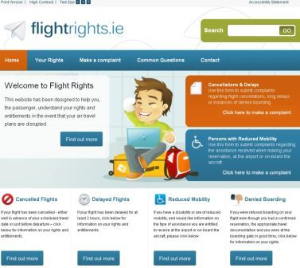
The new website was designed to facilitate easy access to information on the rights of passengers affected by cancellations and delays. It will also provide information on the assistance that persons with disabilities and reduced mobility are entitled to receive. Specifically the website will also facilitate greater use of the Commission’s online complaint system.
Other public awareness endeavours undertaken by the Commission in 2011 included hosting an information stand at the annual Holiday World Fair at the RDS in January and participation in Air Passenger Rights Day at Dublin Airport on 7th July in conjunction with the European Consumer Centre Ireland. Both endeavours provided opportunities to engage with the travelling public and to promote the Regulation.

As in previous years, the Commission continued its monitoring role in relation to Regulation 261, carrying out inspections at each of the Irish airports which currently facilitate commercial traffic. No items of concern were noted during these inspections.

On a pan-European level, 2011 also saw the European Commission commence the initial stages of a revision process of the Regulation. Whilst it is likely that any review of the legislation will take a considerable amount of time and effort, it is clear that all stakeholders welcome this opportunity to refine and improve a document which has the welfare of passengers at its core.

- Summary of VALID Complaints Received
The Commission received 4,084 queries during 2011. While this figure represents a 20.5% reduction on the 2010 figure, it is 64% higher than the 2009 figure of 2495.
If a legacy of the volcanic ash and bad weather crises of 2010 is a heightened awareness of passenger rights amongst the general public, it appears that passengers are still unclear as to which public body is competent to address their various complaints.
Of the 4,084 queries received, 2,954 related to an assortment of baggage, pricing, safety and air carrier policy issues. Notwithstanding the range and number of queries which fell outside its official remit, the Commission responded to all the matters raised referring passengers to the competent authorities where possible.
Figure 1 below compares the monthly pattern of queries in 2011 against that of 2010.

Figure 1: Queries received in 2011 and 2010 by month

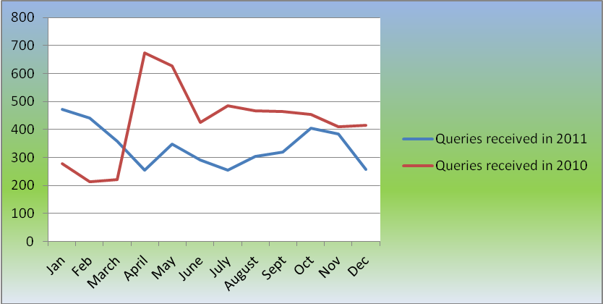

The remaining 1130 queries constituted valid complaints under Regulation 261 and therefore required investigation by the appropriate enforcement body. Table 1 below presents a jurisdictional breakdown of these complaints. The number of complaints which fell to be investigated by the Commission was 626 i.e. the total number of complaints relating to departures from Irish airports together with the total number of complaints relating to arrivals into Irish airports from third countries where those flights were operated by Community licensed carriers.
Table 1: Total number of valid complaints received by the Commission during the period 1st January – 31st December 2011
Origin of flight | Competent  NEB | Number of complaints | %
Departure from an Irish airport | CAR | 599 | 53%
Arrival into an Irish airport from a non-EU airport on a Community licensed carrier | CAR | 27 | 2%
Departure from airport situated in another Member State or arrival into same from a third country on a Community licensed carrier | Other NEB | 504 | 45%
Total |  | 1130 | 100%

- Types of VALID Complaints Received
Valid complaints under EC Regulation 261/ 2004 are those which relate to flight cancellations, long flight delays, instances of denied boarding or of downgrading. Table 2 below provides a breakdown of 1130 complaints received according to these categories.
Table 2: Valid complaints received in 2010 & 2011 by type
Complaint Type | Complaints received in 2011 | Complaints received in 2010 | % Change
Cancellations | 612 | 611 | 0%
Long delay | 303 | 147 | +106%
Denied boarding | 50 | 36 | +38%
Up/ down grading | 2 | 0 | +200%
Other | 163 | 12 | +1260%
Total | 1130 | 806 | +40%

Table 3 and Figure 2 present complaints according to their type.

Table 3: Valid complaints (within the Commission’s responsibility) received in 2010 & 2011 by type
Complaint Type | Complaints received in 2011 | Complaints received in 2010 | % Change
Cancellations | 362 | 182 | +99%
Long delay | 159 | 62 | 156%
Denied boarding | 23 | 14 | +64%
Up/ down grading | 1 | 0 | +100%
Other | 81 | 6 | +1250%
Total | 626 | 264 | +137%

Figure 2: Graph of the figures Table 3

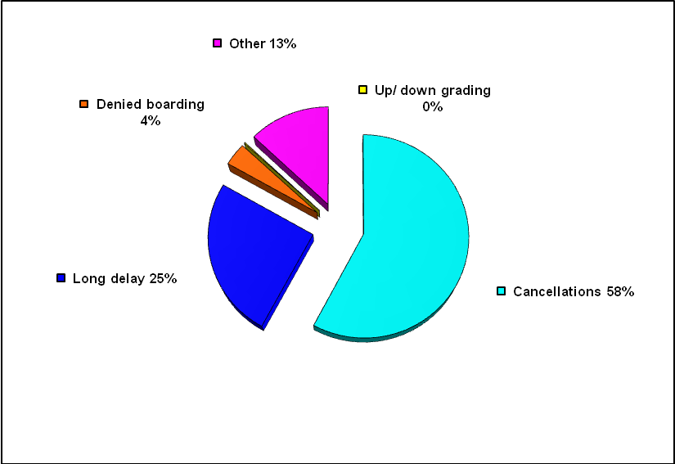
- Resolution of 2011 and earlier COMPLAINTs
By 1st July 2012, 527 of the 626 complaints, received during 2011 and within the Commission’s remit had been investigated and brought to a conclusion. The Commission continues to investigate the remaining 99 cases, although the refund and reimbursement elements in many of these have already been addressed.

Of the 527 cases on which it has concluded, 182 of these were either found to be unsustainable under the Regulation, or withdrawn by the passenger or related to an infringement of the Regulation for which there was no redress available to the passenger.

The table below summarises how many of the remaining 345 complaints resulted in passengers receiving a refund, reimbursement and/or compensation. In the great majority of cases, the air carrier was not required to pay compensation because it could demonstrate that there were ‘exceptional circumstances’ and that it had taken all reasonable measures to avoid the cancellation or delay. Nevertheless, air carriers were required to provide refunds or reimbursements to over half of complainants.

Resolution | Number of Cases
Compensation was paid to the passenger | 61
The air carrier either successfully demonstrated that the exemption in Article 5(3) of the Regulation applied or the delay upon arrival did not exceed 3hrs | 284
The passengers received either a refund of the cost of their ticket or were reimbursed their expenses | 193

Concerning 2010 cases, the Commission has concluded its investigations into 92% of these that fell within its jurisdiction. It is expected that the remaining 8% will be finalised promptly upon receipt of final clarification of issues which have been put before the European Court of Justice.

- 2011 Complaints by airline

The Commission received a total of 1130 complaints from passengers during 2011. Figure 4 below shows the total complaints for Aer Lingus, Aer Arann and Ryanair plus an ‘Other’ category. The ‘Other’ category represents the sum of all complaints in respect of other airlines received by the Commission. Complaints were recorded in respect of 55 other air carriers during 2011.
Figure 3: Total 2011 complaints for Aer Arann, Aer Lingus, Ryanair and Other

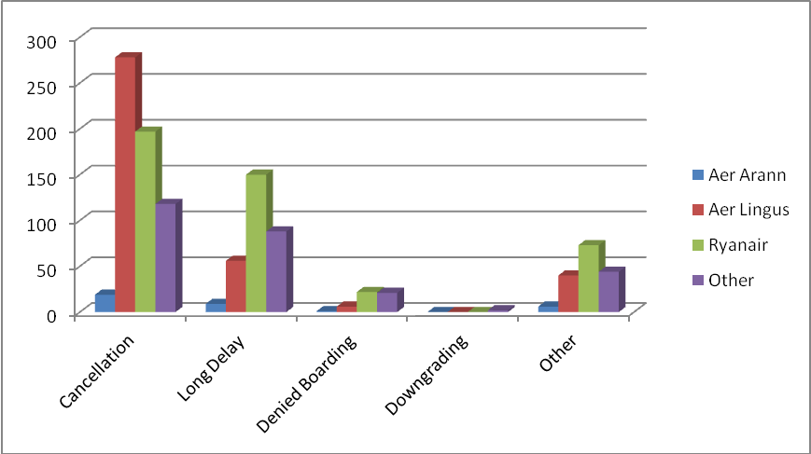

The following table presents an airline breakdown of the 599 complaints received by the Commission relating to departures from Irish airports in 2011.

Table 4: Analysis of 2011 complaints received by Irish Airport

Airport | Total Complaints | Cancellation | Long Delay | Denied Boarding | Down- grading | Other
Cork | 64 | 34 | 20 | - | - | 10
Donegal | 0 | - | - | - | - | -
Dublin | 489 | 282 | 119 | 22 | 1 | 65
Galway | 5 | 1 | 2 | 1 | - | 1
Kerry | 1 | 1 | - | - | - | -
Knock | 20 | 13 | 6 | - | - | 1
Shannon | 19 | 9 | 6 | - | - | 4
Sligo | 0 | - | - | - | - | -
Waterford | 1 | - | 1 | - | - | -
Total | 599 | 340 | 154 | 23 | 1 | 81

Table 5 below analyses the complaints made by passengers departing from Dublin, Cork and Shannon, a total of 572. In 2011, 22.7 million passengers used these airports.

Table 5: 2011 complaints at Dublin, Cork and Shannon Airports

Airline | Total complaints | Total passengers at 3 airports | Complaints per mppa
Aer Arann | 18 | 856,179 | 20.93
Aer Lingus | 234 | 8,759,689 | 26.71
Ryanair | 147 | 8,513,550 | 17.27
Other | 173 | 4,598,575 | 37.69
Total | 572 | 22,727,993 | 25.17
- Complaints Sent to Other EU countries
During 2011, the Commission received 504 valid complaints which related either to departures from airports in other EU countries or to arrivals from third countries into such airports on Community-licensed carriers.
The majority (56%) of complaints received related six other Member States; the UK, Spain, France, Italy and Germany. Figure 5 below illustrates the distribution.
Figure 4: Graphical Representation of percentage complaints referred to other National Enforcement Bodies
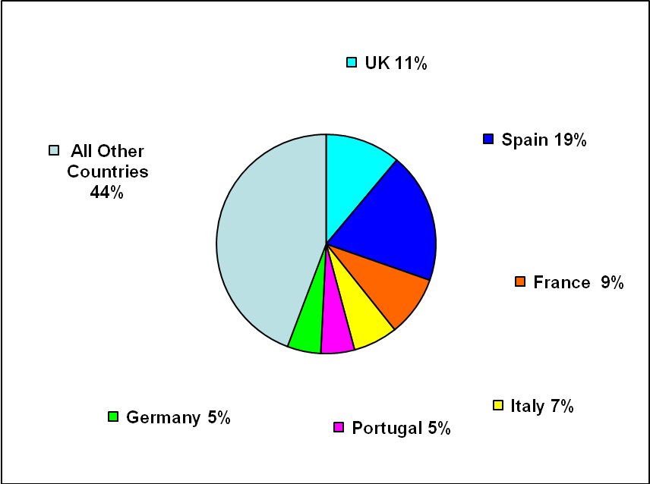

- Persons with reduced mobility (EC REgulation 1107/ 2006)
In July 2011, Regulation 1107 had been in force for three years. Unlike in the case of general air passengers, complaints by those with reduced mobility (PRMs) have to date been modest and more stable. Given the substantial number of PRMs availing of the service at Irish airports, this may be because awareness levels are quite high, and the assistance offered by airlines and airports is working quite smoothly.

To support awareness, the Commission launched a new consumer website http://www.flightrights.ie/ in December 2011.

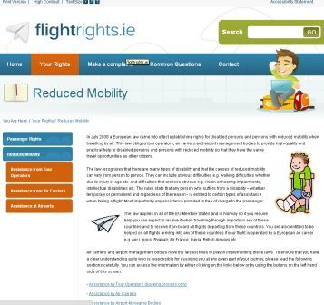
This website contains clear and easily accessible information about the general entitlements of passengers when travelling by air. There is also a large section of the website dedicated solely to PRM rights and entitlements.

While the number of complaints received is quite low, individual cases can be quite complex and time-consuming to resolve. For this reason the European Commission commenced work in 2011 on a set of ‘Interpretative Guidelines’ which would assist stakeholders and enforcement bodies such as this Office with interpretation and application of the legislation. This Office will be working with the European Commission and other enforcement bodies on these Interpretative Guidelines and it is expected that they will be finalised prior to the 2012 Para-Olympics which commence in late August.

The Commission continued its monitoring role in relation to the airport aspects of Regulation 1107 in 2011. Comprehensive inspections were carried out at each of those Irish airports which currently facilitate commercial traffic throughout the year. No items of concern were noted during these inspections.

- Total PRM complaints received
In 2011, there were 21 queries from the public. In most cases, these occurred prior to the booking stage and so did not constitute a possible infringement of the Regulation. In the other five cases, complaints related to assistance received:
- at the time of booking;
- from the airport management body at the airport;
- on-board the aircraft.

Specific complaints related to claims of damaged mobility equipment, refused embarkation, the training received by those providing assistance to persons with reduced mobility and the carriage of mobility equipment.

We investigated four of these complaints; the fifth fell outside of the remit of the Commission and was forwarded to the competent NEB. All four investigations have been concluded. In three cases, we found no infringement; in the fourth case an infringement was noted but the matter was subsequently addressed by the air carrier to the passenger’s satisfaction.

- Conclusion
Public awareness in relation to air passenger rights appears to be on the increase. However further improvement is possible and in the remainder of 2012 we will seek to raise consumer awareness even more.

The Commission will also continue to work with the European Commission to finalise the Interpretative Guidelines for Regulation 1107 as well as contributing to the proposed revision of Regulation 261.

Further information on EC Regulation 261/2004 and EC Regulation 1107/2006 can be found on the Commission for Aviation Regulation’s websites: www.aviationreg.ie and www.flightrights.ie

5,132 queries were received in 2010, many of which directly related to the volcanic ash crisis which occurred in April and May of that year.
Article 16 of Regulation 261/2004 sets out how responsibility for complaint handling is determined. It states that “Each Member State shall designate a body responsible for the enforcement of this Regulation as regards flights from airports situated on its territory and flights from a third country to such airports………”.
Frequently complaints are received by this Office, which initially appear to fall within the remit of Regulation 261/2004 but investigation later reveals that they are more appropriate to be addressed by another authority. The “Other” category represents this group of complaints.
See footnote no. 3.
For example if an air carrier did not provide passengers affected by a cancellation or delay with a written notice of their rights in accordance with Article 14 at the relevant time, then notwithstanding that the air carrier has infringed the Regulation, the situation cannot be rectified after the fact. Similarly in a situation where care and assistance is due to a passenger by virtue of a cancellation, delay or instance of denied boarding and this is not provided within the relevant timeframe, unless the passenger has incurred expense in making their own arrangements which can subsequently be reimbursed by the air carrier then clearly the necessity for the care and assistance has passed.
These figures reflect the total number of complaints received in relation to the named air carriers in respect of departures from Dublin, Cork & Shannon airports only.
These passenger figures relate to Dublin, Cork & Shannon only.

